**WORDPRESS SECURITY PLUGIN**

**Synopsis:**

**WordPress is the most popular and widely used blogging platform for its easy to use features and great community based support. But Security has been the major concern for the WordPress Websites. The important steps to take against the security breach from hackers are to keep the WordPress updated to the latest version. Besides that, below we have listed one of the top WordPress Security Plugins that provide great security features to protect your site from the hackers.**

**iThemes Security Plugin :**

**After installing the plug-in, the plug-in can be configured from the admin dashboard menu as shown in the picture below:**

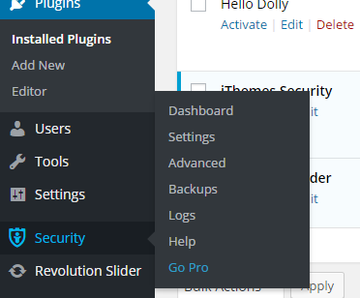

**The plug-in dashboard lets you view the current security status of your site and easy way to fix them. The security issues are categorized as High Priority, Medium Priority & Low Priority. Most of the issues can be fixed with one click button. The snap for the plug-in dashboard is pictured below:**

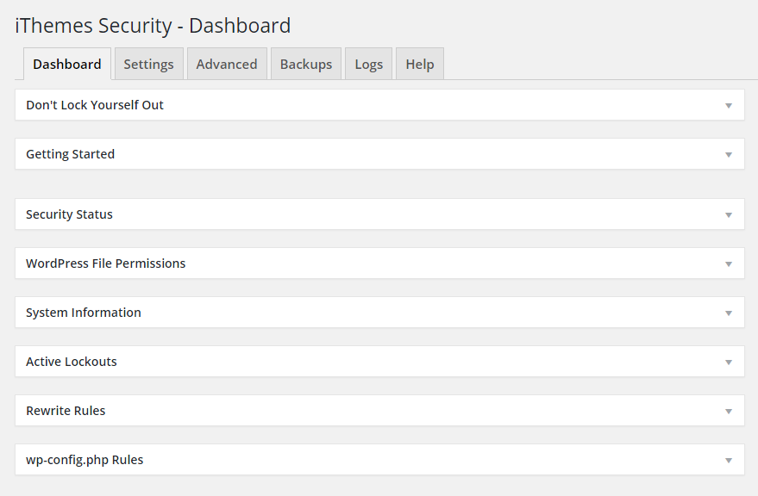**As seen on the above picture, all the handful information is provided in the categorized section in the dashboard of plug-in. Issues can be fixed with one click button from the dashboard under the “Security Status” section. 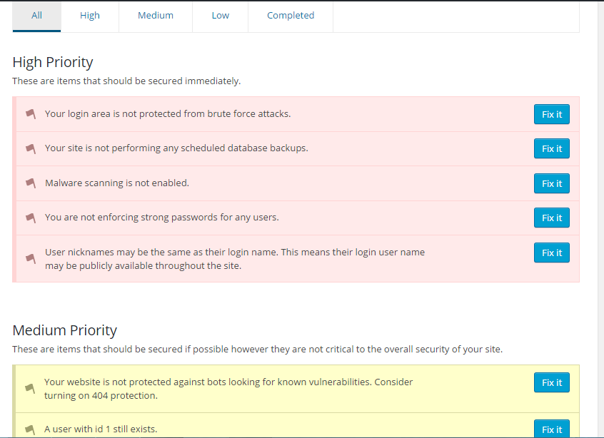The “Settings” tab lets you configuring settings for Brute Force Protection, File Change Detection, Database Backups, and Malware Scanning etc. The settings screen is also categorized and provides easy fixing.**

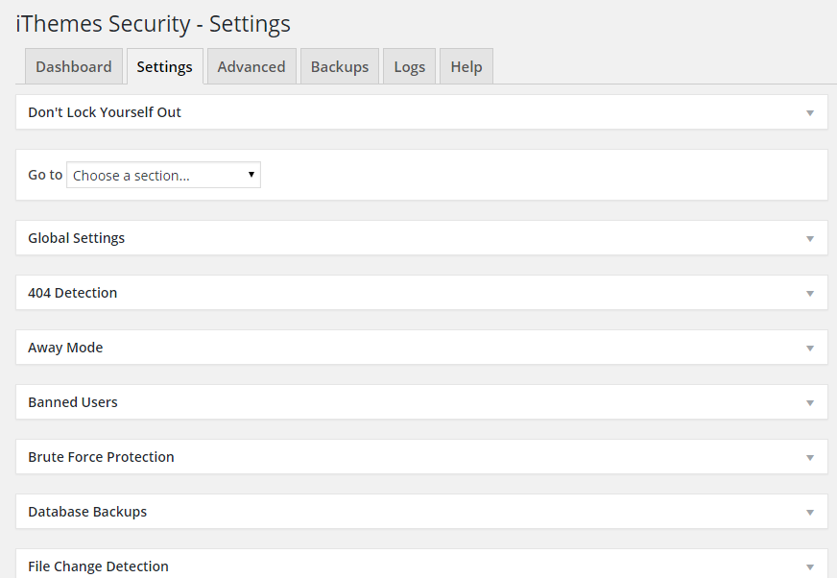**The “Advanced” tab lets user to configure the content directory, changing the database prefix and other user related settings.**

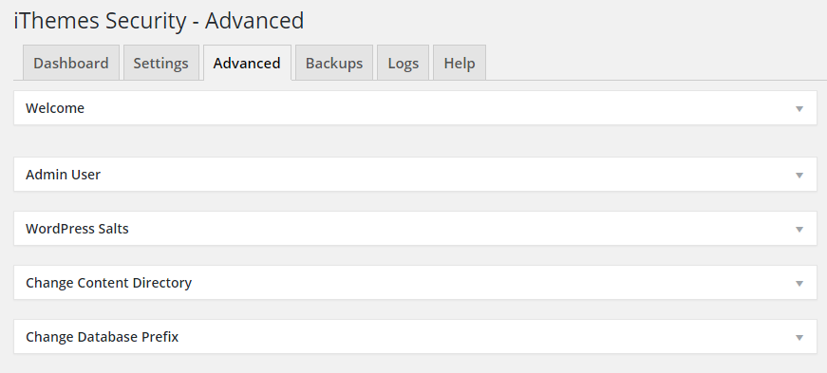 **The plug-in also recommends and suggests good backup Plugins before making changes to the site. It also logs the site & user activity which can be viewed under the “Logs” tab.**

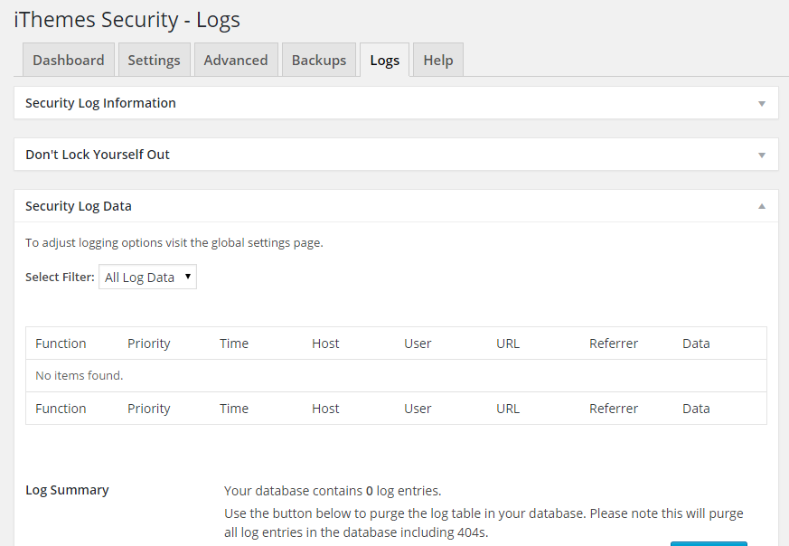**The plug-in has good product support and has more than 6, 00,000 plus active installations. The detailed features can be found on their website at** [**https://ithemes.com/security/**](https://ithemes.com/security/) **and the Plugins can be downloaded from WordPress plugin repository link** [**https://wordpress.org/plugins/better-wp-security/**](https://wordpress.org/plugins/better-wp-security/)